

Servicio Nacional de Aprendizaje
Red de conocimiento informática, diseño y desarrollo de software

Tecnólogo en Análisis y Desarrollo de Software
Título del Proyecto Formativo

Instructor
Edwar Velásquez, Ing. Mecatrónico y
Magister en Tecnología Educativa.

2026 – Colombia 
Procedimiento Backend
Primero crear la base de datos en Postgres.
backend/database/boda_edwar_nana
-- =========================
-- EXTENSIONES
-- =========================
CREATE EXTENSION IF NOT EXISTS "uuid-ossp";

-- =========================
-- TABLA: invitations
-- =========================
CREATE TABLE invitations (
id UUID PRIMARY KEY DEFAULT uuid_generate_v4(),
token TEXT UNIQUE NOT NULL,
main_guest_name TEXT NOT NULL,
created_at TIMESTAMP DEFAULT NOW()
);

-- =========================
-- TABLA: guests
-- =========================
CREATE TABLE guests (
id UUID PRIMARY KEY DEFAULT uuid_generate_v4(),
invitation_id UUID NOT NULL,
name TEXT NOT NULL,
is_main BOOLEAN DEFAULT FALSE,

CONSTRAINT fk_invitation
FOREIGN KEY (invitation_id)
REFERENCES invitations(id)
ON DELETE CASCADE
);

-- =========================
-- TABLA: attendance
-- =========================
CREATE TABLE attendance (
id UUID PRIMARY KEY DEFAULT uuid_generate_v4(),
invitation_id UUID NOT NULL,
guest_id UUID NOT NULL,
attending BOOLEAN NOT NULL,
confirmed_by TEXT NOT NULL,
confirmed_at TIMESTAMP DEFAULT NOW(),

CONSTRAINT fk_invitation_attendance
FOREIGN KEY (invitation_id)
REFERENCES invitations(id)
ON DELETE CASCADE,

CONSTRAINT fk_guest_attendance
FOREIGN KEY (guest_id)
REFERENCES guests(id)
ON DELETE CASCADE
);

-- =========================
-- ÍNDICES (performance real)
-- =========================
CREATE INDEX idx_invitation_token ON invitations(token);
CREATE INDEX idx_guests_invitation ON guests(invitation_id);
CREATE INDEX idx_attendance_invitation ON attendance(invitation_id);

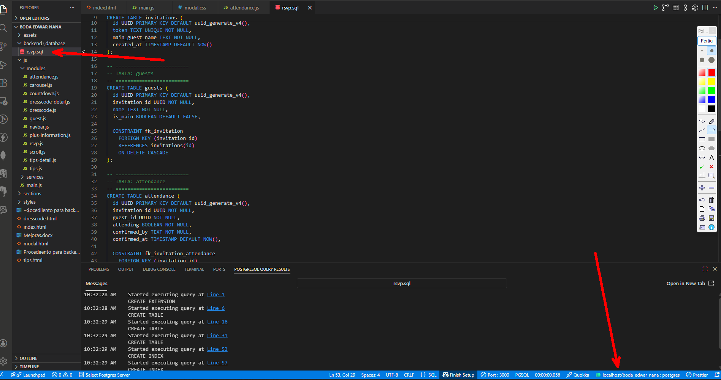

Instalar
npm init -y
npm install express pg dotenv cors

